**LAB #06:**

**Name:_sidra nasir_________________ Reg #:f2025-0792_________________ Marks:**

# Lab6:Switch case, nested if, if else if

## Q1: Write a program that prompts the user to input three numbers and then displays them in ascending order (from smallest to largest). CLO1, CLO2

|  |
| --- |
| #code here  #include <iostream>  using namespace std;  int main() {  int a, b, c;  cout << "Enter three numbers: ";  cin >> a >> b >> c;  if (a <= b && a <= c) {  if (b <= c)  cout << "Ascending order: " << a << " " << b << " " << c;  else  cout << "Ascending order: " << a << " " << c << " " << b;  }  else if (b <= a && b <= c) {  if (a <= c)  cout << "Ascending order: " << b << " " << a << " " << c;  else  cout << "Ascending order: " << b << " " << c << " " << a;  }  else {  if (a <= b)  cout << "Ascending order: " << c << " " << a << " " << b;  else  cout << "Ascending order: " << c << " " << b << " " << a;  }  return 0;  } |

## Q2: What is the output of the following program: CLO1, CLO2

|  |
| --- |
| Write output here:  7  === Code Execution Successful === |

#include <iostream>  
using namespace std;  
  
int main() {  
 int b = 6, c = 5;  
 if (b++ >= 7 && ++c == 5)  
 b += c;  
 else  
 cout << b-- << endl;  
 return 0;  
}

## A screen shot of a computer program AI-generated content may be incorrect.Q3: What is the output of the following program: CLO1, CLO2

nq

|  |
| --- |
| Write output here:  5010050100  === Code Execution Successful === |

/

## Q4: What is the output of the following program: CLO1, CLO2

|  |
| --- |
| Write output here:  3  === Code Execution Successful === |

#include <iostream>  
using namespace std;  
int main() {  
 int n = 0;  
 if ('A' == 'a')  
 n = 1;  
 else if ('A' > 'a')  
 n = 2;  
 else  
 n = 3;  
 cout << n << endl;  
 return 0;  
}

## Q5: Evaluate the following: CLO1, CLO2

|  |  |  |
| --- | --- | --- |
| **Sr** | **Expression** | **Result** |
| A | 6 <= 6) && (5 < 3) | false |
| B | (6 <= 6) || (5 < 3) | false |
| C | (5 != 6) | true |
| D | (5 < 3) && (6 <= 6) || (5 !=6) | true |
| E | (5 < 3) && ((6 <= 6) || (5 !=6)) | false |
| F | !((5 < 3) && ((6 <= 6) || (5 !=6))) | true |
| G | !(12 > 25) && !(18 < 17) | true |

## Q6: Speed of Sound in Gases: (First solve Q6 then solve Q5) CLO1, CLO2

|  |  |
| --- | --- |
| Gas | Speed (m/s) |
| Carbon dioxide | 258.0 |
| Air | 331.5 |
| Helium | 972.0 |
| Hydrogen | 1,270.0 |

Write a program that displays a menu so the user can select one of the gases listed above.  
After the choice, the user enters the **time (in seconds)** it took for the sound to travel from the source to the receiver.

The program should compute and display the **distance** using:

$$\text{Distance}=\text{Speed}×\text{Time}$$

**Input Validation**

* Only accept valid menu choices.
* Time must be **between 0 and 30 seconds** (inclusive).

**Write code in if else if and switch case.**

|  |
| --- |
| #if else if code here  #include <iostream>  #include <iomanip>  using namespace std;  int main() {  int choice;  double time, distance;  const double carbonDioxide = 258.0, air = 331.5, helium = 972.0, hydrogen = 1270.0;  cout << "Speed of Sound in Gases\n";  cout << "1. Carbon Dioxide\n";  cout << "2. Air\n";  cout << "3. Helium\n";  cout << "4. Hydrogen\n";  cout << "Enter your choice (1-4): ";  cin >> choice;  if (choice >= 1 && choice <= 4) {  cout << "Enter time (seconds): ";  cin >> time;  if (time < 0 || time > 30) {  cout << "Error: Time must be between 0 and 30 seconds.";  return 0;  }  if (choice == 1)  distance = carbonDioxide * time;  else if (choice == 2)  distance = air * time;  else if (choice == 3)  distance = helium * time;  else  distance = hydrogen * time;  cout << fixed << setprecision(2);  cout << "Distance: " << distance << " meters\n";  }  else {  cout << "Invalid input! Please choose between 1 and 4.";  }  return 0;  } |

Switch case code:

|  |
| --- |
| #switch case code here  #include <iostream>  #include <iomanip>  using namespace std;  int main() {  int choice;  double time, distance;  const double carbonDioxide = 258.0, air = 331.5, helium = 972.0, hydrogen = 1270.0;  cout << "Speed of Sound in Gases\n";  cout << "1. Carbon Dioxide\n";  cout << "2. Air\n";  cout << "3. Helium\n";  cout << "4. Hydrogen\n";  cout << "Enter your choice (1-4): ";  cin >> choice;  if (choice >= 1 && choice <= 4) {  cout << "Enter time (seconds): ";  cin >> time;  if (time < 0 || time > 30) {  cout << "Error: Time must be between 0 and 30 seconds.";  return 0;  }  switch (choice) {  case 1:  distance = carbonDioxide * time;  cout << "Gas: Carbon Dioxide\n";  break;  case 2:  distance = air * time;  cout << "Gas: Air\n";  break;  case 3:  distance = helium * time;  cout << "Gas: Helium\n";  break;  case 4:  distance = hydrogen * time;  cout << "Gas: Hydrogen\n";  break;  }  cout << fixed << setprecision(2);  cout << "Distance: " << distance << " meters\n";  }  else {  cout << "Invalid input! Please choose between 1 and 4.";  }  return 0;  } |

## Q7: Speed of Sound in Different Mediums CLO1, CLO2

|  |  |
| --- | --- |
| **Medium** | **Speed** |
| Air | 1,100 feet per second |
| Water | 4,900 feet per second |
| Steel | 16,400 feet per second |

Write a program that displays a menu for the user to select one of three mediums: **Air**, **Water**, or **Steel**. After the user makes a selection, ask for the **distance** (in feet) a sound wave will travel in that medium. The program should then calculate and display the **time** required for sound to travel that distance. Use the formula:

$$\text{Time}=\frac{\text{Distance}}{\text{Speed}}$$

Round the result to **four decimal places**.

**Input Validation**

* The user must select a **valid menu option**.
* The distance entered must be **greater than or equal to 0**.

|  |
| --- |
| #solution code in if else if:  #include <iostream> #include <iomanip> using namespace std;  int main() {  int choice;  double distance, time;  const double air = 1100, water = 4900, steel = 16400;  cout << "Speed of Sound Calculator\n";  cout << "1. Air\n";  cout << "2. Water\n";  cout << "3. Steel\n";  cout << "Enter your choice (1-3): ";  cin >> choice;  if (choice >= 1 && choice <= 3) {  cout << "Enter distance (feet): ";  cin >> distance;   if (distance < 0) {  cout << "Error: Distance cannot be negative.";  return 0;  }  if (choice == 1)  time = distance / air;  else if (choice == 2)  time = distance / water;  else  time = distance / steel;  cout << fixed << setprecision(4);  cout << "Time taken: " << time << " seconds\n";  }  else {  cout << "Invalid input! Please choose 1, 2, or 3.";  }  return 0; } |

**The above Speed of Sound in Different Mediums program given code in if else if, please modify above code in switch case.**

|  |
| --- |
| #code here  **#include <iostream>**  **#include <iomanip>**  **using namespace std;**  **int main() {**  **int choice;**  **double distance, time;**  **const double air = 1100, water = 4900, steel = 16400;**  **cout << "Speed of Sound Calculator\n";**  **cout << "1. Air\n";**  **cout << "2. Water\n";**  **cout << "3. Steel\n";**  **cout << "Enter your choice (1-3): ";**  **cin >> choice;**  **if (choice >= 1 && choice <= 3) {**  **cout << "Enter distance (feet): ";**  **cin >> distance;**  **if (distance < 0) {**  **cout << "Error: Distance cannot be negative.";**  **return 0;**  **}**  **switch (choice) {**  **case 1:**  **time = distance / air;**  **cout << "Medium: Air\n";**  **break;**  **case 2:**  **time = distance / water;**  **cout << "Medium: Water\n";**  **break;**  **case 3:**  **time = distance / steel;**  **cout << "Medium: Steel\n";**  **break;**  **}**  **cout << fixed << setprecision(4);**  **cout << "Time taken: " << time << " seconds\n";**  **}**  **else {**  **cout << "Invalid input! Please choose 1, 2, or 3.";**  **}**  **return 0;**  **}** |

## Q8: Write code from flowchart. CLO1, CLO2

You are given a flowchart that compares three numbers and determines the **largest among them**.

Using the logic shown in the given flowchart, write a **C++ program using nested if statements** to input three numbers and display the **largest number**.

**Note:** You must follow the flowchart structure and use nested if conditions (not if-else-if or max functions).

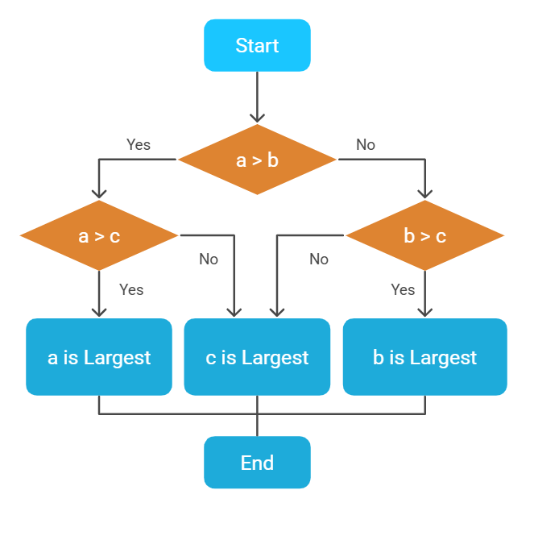

|  |
| --- |
| #code here  #include <iostream>  using namespace std;  int main() {  int a, b, c;  cout << "Enter three numbers: ";  cin >> a >> b >> c;  if (a > b) {  if (a > c)  cout << "a is the largest number.";  else  cout << "c is the largest number.";  }  else {  if (b > c)  cout << "b is the largest number.";  else  cout << "c is the largest number.";  }  return 0;  } |